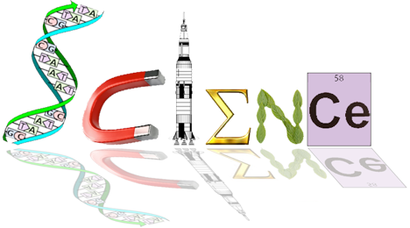

**Human Biology Year 12**

**ATHBY 2021**

**Task 2: Endocrine and Nervous System and Homeostasis Test**

**Name: Date: /64**

**Multiple Choice Section: (14 marks)**

1. The cerebral cortex is mainly concerned with which of the following?
2. connecting the left and right hemispheres
3. conscious sensory awareness and voluntary movement
4. control of the endocrine system
5. control of both the parasympathetic and sympathetic nervous systems
6. People who have suffered physical damage to the cerebellum would be expected to show symptoms such as:
7. a low intelligence
8. uncoordinated jerky movements
9. a lack of autonomic nervous system functioning
10. no memory
11. The effectors associated with negative feedback models include:
12. the nervous and endocrine systems
13. the body fluids
14. glands and muscles
15. all body tissues
16. When the hormone cortisol reaches a target cell, it enters the cell and combines with a receptor protein inside the cell. The combined substance enters the nucleus, where it activates genes to produce a protein. Thus, cortisol is a:
17. water soluble amine
18. water soluble steroid
19. lipid soluble amine
20. lipid soluble steroid
21. At resting potential, the ion distribution inside and outside of a neuron is such that __________ ions are most abundant on the outside of the cell, while __________ ions are most abundant on the inside of the cell.
22. potassium; sodium
23. sodium; potassium
24. calcium; phosphate
25. sulfate; potassium

Question 6 refers to the graph below

Antidiuretic hormone is important in controlling water balance. The graph shows changes in the concentration of antidiuretic hormone as plasma solute concentration changes.



1. The change in antidiuretic hormone in the blood plasma at 285 mOs/kg was due to
   1. an increase in osmotic pressure in the cells
   2. a decrease in the solute concentration of the plasma
   3. an increased intake of water into the cells
   4. a decrease in osmotic pressure in the plasma
2. Aldosterone is a hormone found in the **adrenal medulla** which acts on the **liver** to increase the amount of sodium. The statement would be correct if some or all of the words in bold were replaced with these words
   1. adrenal cortex and kidney
   2. kidney and decrease
   3. adrenal cortex, kidney, decrease and potassium
   4. adrenal cortex, kidney and decrease
3. Which of the following statements concerning the control of blood gases is correct?
   1. The carbon dioxide concentration produces the most immediate effect.
   2. The carotid and aortic bodies respond rapidly to the blood oxygen concentration.
   3. Hydrogen ion receptors are found only in the carotid artery.
   4. A more rapid rate of breathing is produced when the hydrogen ion concentration increases.
4. Which of the below hormones can directly promote physiological responses to help LOWER blood glucose levels?
   1. Thyroid Regulating Hormone (TRH), Prolactin, Thyroxine
   2. Adrenaline, TSH, ACTH
   3. Cortisol, Calcitonin, Oestrogen
   4. Thyroxine, Cortisol, Adrenaline
5. After a meal of fish and chips with lots of salt which of the following would be true?
   1. More sodium would be present in the urine
   2. The secretion of aldosterone from the adrenal cortex would decrease
   3. The secretion of adrenalin from the adrenal cortex would decrease
   4. Both (a) and (b) above
6. After a series of deep inhalations and exhalations (i.e. forced breathing) there is a period of reduced breathing rate because the

a) nitrogen concentration of the blood has increased

b) CO2 concentration of the blood has increased

c) CO2 concentration of the blood has decreased

d) O2 concentration of the blood has decreased

1. After running hundreds of metres an athlete continues to breathe hard for some minutes because

a) the high level of oxygen in the blood stimulates the cardiovascular centre to increase the breathing rate

b) the low level of bicarbonate ions in the blood stimulates receptors in the carotid and aortic bodies to increase the breathing rate

c) the high level of carbon dioxide in the blood stimulates the receptors in the medulla increase the breathing rate

d) he needs to lower down the body temperature because of the excess heat

1. If a drug completely destroyed the cells of a man’s pancreas, we would expect to find a

a) high concentration of glucose in his blood and in his urine

b) normal concentration of glucose in his blood and a high concentration in his urine

c) high concentration of glucose in his blood, but low concentration in his urine

d) low concentration of glucose in both blood and urine

1. When glucose molecules are chemically combined in long chains to form glycogen the process is known as

a) gluconeogenesis

b) glycogenolysis

c) respiration

d) glycogenesis

**Short Answer: 34 marks**

21a) Provide one difference between the Autonomic and Somatic Nervous System divisions. (1 marks)

The answer must contain both the autonomic and somatic part (1)

not just something like somatic effects skeletal muscle and autonomic does not – this would get 0 marks

|  |  |
| --- | --- |
| **Division of Nervous system** | **Differences between the Divisions** |
| Autonomic NS | Involuntary / 2 neurotransmitters –noradrenaline, acetylcholine /  Pathway from CNS to organ consists of 2 neurones |
| Effectors smooth muscle, glands, cardiac muscle |
| Somatic NS | Voluntary / neurotransmitter acetylcholine / Pathway from CNS to skeletal muscles 1 neurone |
| Effectors skeletal muscle |

One of the types of neurons involved in the reflex arc is classified as unipolar.

The diagram below shows the general structure of a unipolar neuron.



b) Name the type of neuron that is pseudo unipolar and explain why it is classified as unipolar

(2 marks)

Sensory (1)

Has one extension, an axon / dendrites and axon are continuous / cell bodies lies to the side (1)

22. The diagram below shows the relationship between the hypothalamus and the pituitary gland.





a) Describe the process leading to secretion of hormones from the anterior lobe into the bloodstream. (3 marks)

Hypothalamus act as a receptor (1)

Hypothalamus secretes releasing and inhibiting factors - carried via blood to ALP (1)

Stimulated ALP to release hormones (1)

b) Explain why the posterior lobe is not considered to be a true endocrine gland. (2 marks)

(2 marks)

Antidiuretic & Oxytocin produced in special nerve cells in hypothalamus. (1)

Hormones travel down nerve extension to PLP and are stored ready for release. (1)

c) Use the two hormones released by the anterior lobe of the pituitary gland to complete the following table. (2 marks)

One mark per row.

|  |  |  |
| --- | --- | --- |
| Adrenocorticotrophic  hormone (ACTH) | Adrenal cortex | Secretion of hormones from the adrenal cortex (1) |
| Luteinizing hormone  (LH) | Ovaries  Testes | Ovulation and maintenance of corpus luteum  Secretion of testosterone (1) |

23. Refer to the following diagram for question 23.



a) Alzheimer’s disease is a form of dementia that can cause memory loss, confusion and mood swings. Given these symptoms of Alzheimer’s disease, which part of the brain (labelled A-D) above would you expect to be most affected by this disease? (1 mark)

A

b) Although different diseases, Alzheimer’s disease and Parkinson’s disease are similar in that they both affect the brain. There are also similarities in the causes and effects of these diseases.   
State one such similarity between Alzheimer’s disease and Parkinson’s disease. (1 mark)

Caused by deficiency of neurotransmitters - P dopamine A acetylcholine or effect some memory loss in elderly

c) The nervous and endocrine systems work together to coordinate functions of all body systems. However, they differ in several ways.

Complete the table below to outline three of these differences. (3 marks)

Each row (1) students must have both parts for the mark.

|  |  |  |
| --- | --- | --- |
| **Characteristic** | **Nervous System** | **Endocrine System** |
| Speed of action | Fast | Slow |
| Duration of action | Short Term | Long Term |
| Specificity of message | Localised | Widespread |

d) Tabun is an extremely toxic synthetic organophosphorus compound. It is a clear, colourless, and tasteless liquid with a faint fruity odour. It is classified as a nerve agent because it fatally interferes with normal functioning of the mammalian nervous system. Using your knowledge of the functions of the nervous system, complete the table below by identifying where the dysfunction would most likely have occurred to bring about the stated symptoms. Provide a scientific reason for your choice. (6 marks)

One mark per box totally 6

|  |  |  |
| --- | --- | --- |
| **Tabun Symptoms** | **Structure/s of the nervous system affected** | **Reason** |
| Excessive sweating | Hypothalamus | Control centre of sweat glands. Would be stimulated to cause greater sweating. |
| Respiratory failure | Medulla Oblongata | Control centre of breathing. Would be stimulated to slow/stop breathing |
| Blurred vision | Optic nerve  **OR**  Occipital lobe | Damage to sensory pathway causing blurring  Damage to processing of sensory information causing blurred vision |

Refer to the diagram below to answer question 24.

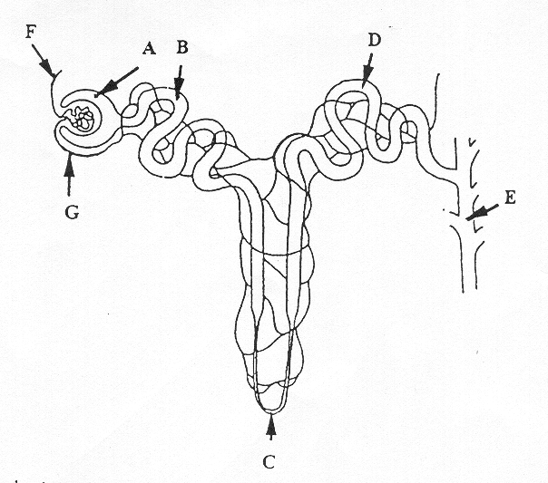

24. a) Name the two hormones that act on BOTH parts C and D. State where they are produced and describe their function. (6 marks)

Any two of the below 3 hormones:

|  |  |  |  |
| --- | --- | --- | --- |
| **Name** | **Production Site** | **Function** | **Max Mark** |
| Aldosterone | Adrenal Cortex | Increase salt reabsorbed into capillaries | 3 |
| Parathyroid hormone | Parathyroid glands | Increase Calcium reabsorption | 3 |
| Cortisol | Adrenal cortex | Increase salt reabsorbed into capillaries | 3 |

b) Explain how one of the hormones you identified in part (a) is regulated. (3 marks)

|  |  |
| --- | --- |
| **Descriptions** | **Marks** |
| Aldosterone release is stimulated by a decrease in blood sodium levels,  An increase is ACTH  blood volume,  or blood pressure,  or an increase in blood potassium levels. | 3 (any 3) |
| Parathyroid hormone release is stimulated by a **decrease** in Ca2+ concentration in blood  Causing receptors on parathyroid cells to be activated  An increase in PTSH released by anterior pituitary | 3 (any 3) |
| Cortisol release is stimulated by hypothalamus  Causing release of Cortisol Releasing Hormone from hypothalamus  Causing release of ACTH from anterior pituitary  Causing release of cortisol from adrenal cortex | 3 (any 3) |

25. Complete the following table on the feedback loop. (6 marks)

|  |  |
| --- | --- |
| **Component** | **Description** |
| Stimulus | A change in the environment that causes or could cause a physiological change away from homeostatic tolerance parameters |
| Receptor | Stimulus is detected by sensory cells |
| Modulator | Manages the physiological or behavioural response |
| Effector | Muscle or glands receive the message from the modulator |
| Response | The actions carried out by systems/organs/tissues to return to homeostasis |
| Feedback | The response changes the original stimulus, either decreasing or increasing it. |

**Extended Answer: 16 marks**

a) Explain how the nervous and endocrine systems maintain the body’s internal temperature when it is in danger of falling below the tolerance limits. Ensure your answer includes **two** nervous mechanisms and **one** endocrine mechanism. (10 marks)

b) Thermoregulation can also be assisted by behavioural mechanisms. Identify **three** behaviours that lower internal temperature when it is in danger of rising above tolerance limits and outline how each of these assists in maintaining internal temperature. (6 marks)

General

Thermoreceptors in hypothalamus detect decrease in internal temperature (for 1)

Endocrine Thyroid

Any five of for 5:

Hypothalamus releases releasing factor(TSHRF)

Stimulates anterior pituitary

Anterior pituitary releases thyroid stimulating hormone (TSH)/Stimulates thyroid gland

Produces thyroxine/thyroxine

Secreted into blood

Increased metabolic rate

Increased heat production

or

Adrenal medulla

Any five of for 5:

Hypothalamus sends impulses via sympathetic nerves

To adrenal medulla

Produces adrenaline/noradrenaline

Secreted into blood

Increases metabolic rate

Increased heat production

Nervous

Shivering

Any four of for four:

Hypothalamus sends impulses to parts of brain controlling muscle tone/hypothalamus sends impulses to cerebellum/hypothalamus sends impulses to medulla

Transmission by somatic nerves/to skeletal muscle

Shivering/fast rhythmic muscle contraction

Increased heat production

Hypothalamus sends impulses via sympathetic nerves

Vasoconstriction of skin arterioles/skin blood vessels constrict/reduce diameter

Reduced heat loss

Part B

One mark for the behaviour and one mark for saying how it lowers temperature

Totally 6 marks

